Worksheet 6 Big data

Task 1
1. Explain what is meant by these three characteristics of Big Data:
(a) Volume
The fact that data is too large to be stored in a single server

(b) Velocity
Continous streans of data being collected in real time. The speed of the data being generated

(c) Variety
Data being in many many formats

2. Why can “Big Data” not be held in a traditional database structure?
They don’t scale well, the data would have to be ordered into a row and column structure.
Too complext for standard relational databases

3. Research examples of Big Data and Smart Cities and make notes about what you can find out about.
Summarise your findings in a one-minute presentation.
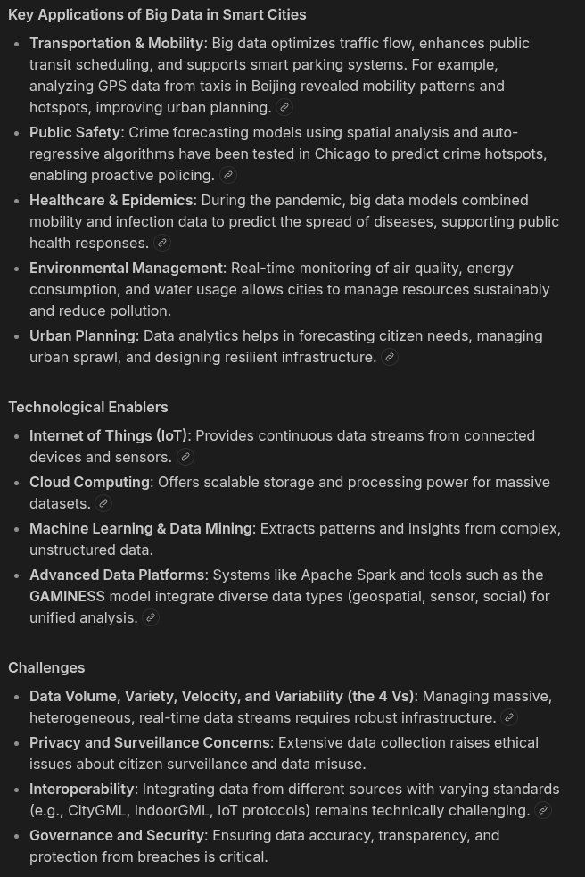
Task 2
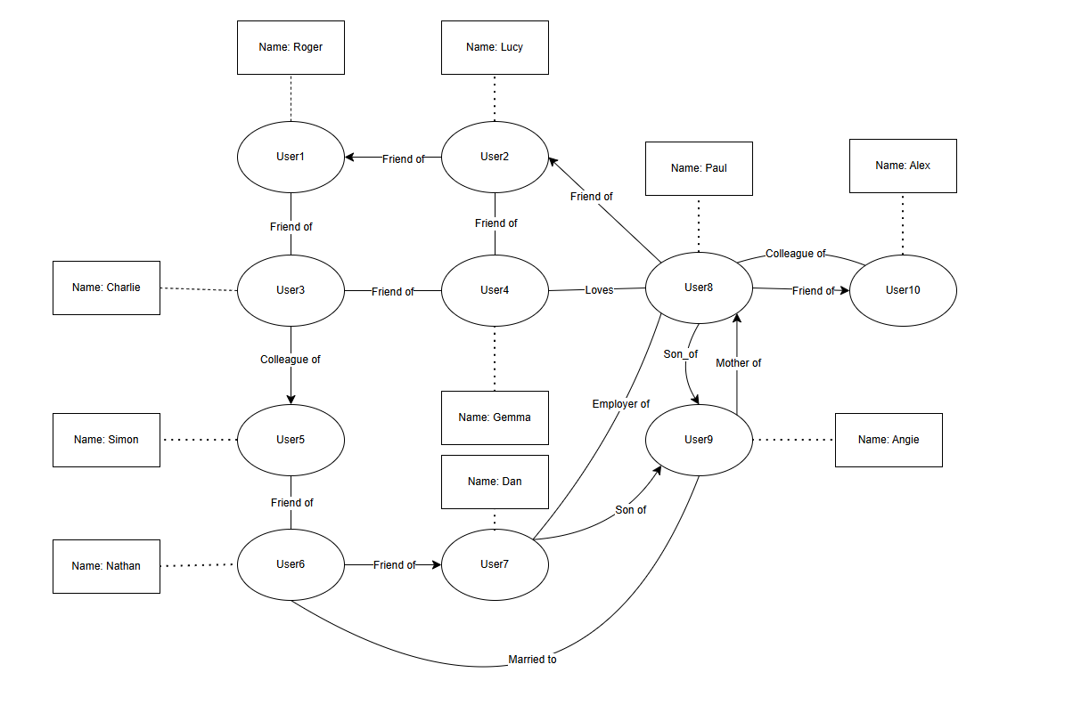
2. How many degrees of separation are there between Roger and Angie?
2

3. Identify some of the nodes, edges and properties of the above graph.

User 5 is Simon and is a friend of User 6, Nathan

4. Discussion: can ‘colleague_of’ work in only one direction? Can ‘employer_of’ work in both directions? Are human relationships simple to define – or immutable?
colleague_of is bi-directional, employer_of is uni-directional. Human relationships can change.

Task 3
A supermarket chain uses a system which stores details of all of the products that it sells and the sales that it makes.
The data that the supermarket stores is Big Data.
The graph schema in the figure below represents part of a fact-based model of the dataset that the supermarket has built.

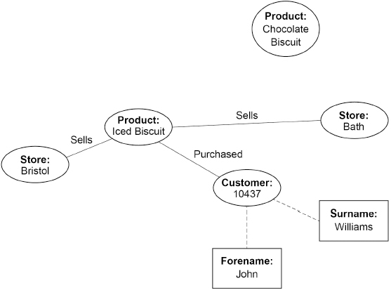

Modify the graph schema in the figure above to represent the following additional facts.
• The Bath store sells chocolate biscuits.
• There are 20 individual biscuits in a packet of iced biscuits and each packet costs £1.50
• Both chocolate biscuits and iced biscuits are made by the company Delicious Snacks. The company has 75 employees and also makes cake bars.
Task 4

In a fact-based model, data is represented as atomic facts, which are immutable (ie will never change). Fact-based models can be represented visually using a graph schema.
The figure below shows part of a graph schema for a data set about deliveries made to stores by trucks.
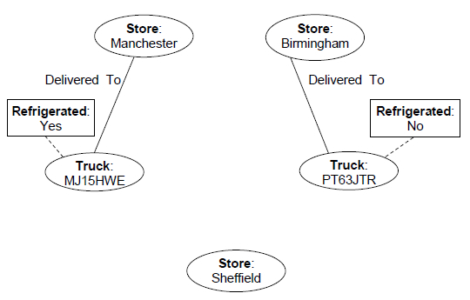
Complete the graph schema in the figure above to represent the following additional facts.
• Truck MJ15HWE has made a delivery to the Sheffield store.
• Truck PT63JTR was last serviced on 10 May 2018 and truck MJ15HWE was last serviced on 18 March 2018.
• Both of the trucks are owned by a haulage company called Ferguson’s which has 15 employees and has a head office in Bolton.

